Information on tourist spots around Ojiya

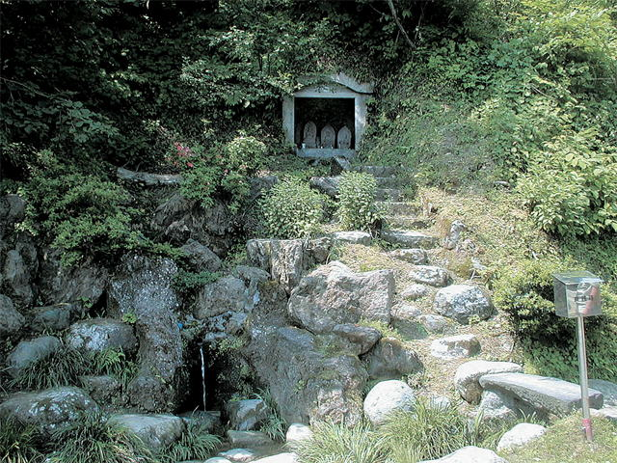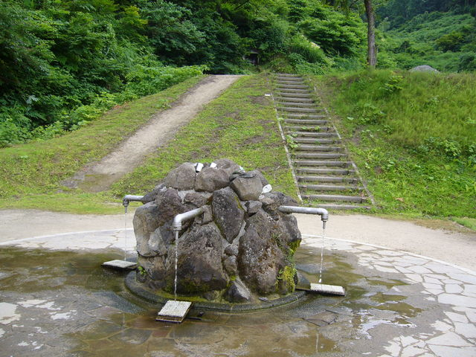
Baba-Shimizu (baba spring water)

Baba-shimizu is spring water gushing out from near the entrance to the path up to the remains of Tokimizu castle in Nishiyama mountain range. It was used for drinking water at the castle back then and was even called “the water that cure illness”.
It goes excellent with coffee and tea. I’m sure you will love it!
Sake breweries in Ojiya use spring water from the same mountain range.

